Headgear Rule for Girls’ Lacrosse Ignites Outcry
Sydney Steinberg (8) positioning herself to score in a game in Gainesville, Fla., which became the first state to mandate that lacrosse players must wear protective head gear.
Rob C. Witzel for The New York Times

By BILL PENNINGTON

March 30, 2015
Worried about the risk of serious head injuries in a sport where the players wield reinforced sticks and rifle shots with a hard, unyielding ball, Florida last month became the first state to require high school girls’ lacrosse teams to wear protective headgear.
Boys’ lacrosse teams nationwide have worn hard-shell helmets for many years. Girls, who play by vastly different rules that generally forbid contact, have historically spurned most protective gear. In Florida, where lacrosse is a new sport, state officials instead reasoned that all lacrosse players are at risk for head trauma and defied the sport’s traditionalists by mandating a soft form of headgear for everyone in a girls’ lacrosse game or practice. (Goalies in girls’ lacrosse have worn helmets for several decades.)
But in a volatile example of how thorny and tangled the debate can become as communities nationwide implement new rules to protect the brains of young athletes, Florida’s mandate has created a combative firestorm that has reverberated across the country.
Ann Carpenetti, vice president of lacrosse operations at US Lacrosse, the sport’s national governing body, called Florida’s decision “irresponsible” and said the headgear decision could make the game more hazardous because it might embolden players to be more aggressive.
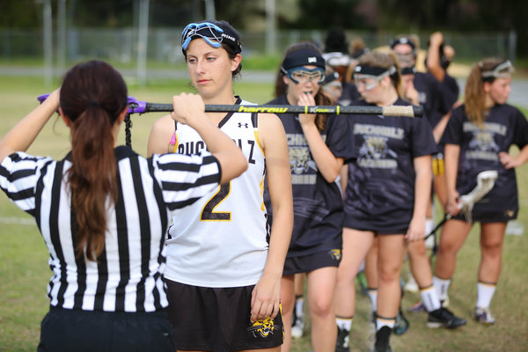
A referee checking equipment before a game.
Rob C. Witzel for The New York Times
Coaches across the state have panned the new rule.
“It serves no purpose, other than being a costly distraction to parents and the players,” said Nikki Krakower, the coach of the girls’ team at Gainesville High School. “It’s ridiculous.”
Opponents of the mandate said the new rule was especially flawed because the Florida-approved headgear — the type used most commonly is a 10-millimeter-thick headband — is flimsy.
“A headband is only going to prevent minor contusions and abrasions if they happen in the two inches the headband covers,” said Lynn Millinoff, the coach of the girls’ team at Buchholz High School in Gainesville. “But Florida officials seem to think they’re smarter than the entire rest of the lacrosse-playing world.”
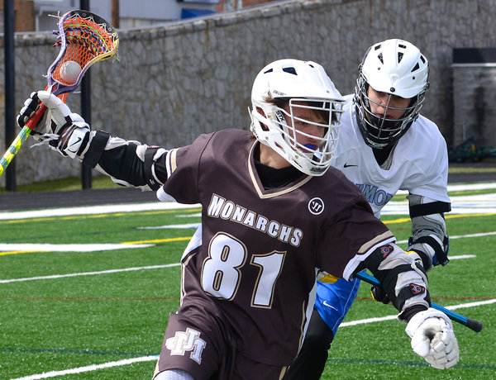
Boys’ high school lacrosse teams in West Virginia wearing hard-shell helmets, a practice boys’ teams have followed for years across the United States.
Tammy Shriver / Times West Virginian, via Associated Press
An online petition denouncing the new rule garnered more than 3,500 signatures.
Conflicting Viewpoints
Many of the athletes, who since February have played hundreds of games with the headgear, are not happy.
“Most of us feel like the headgear is unnecessary and doesn’t do anything except get in the way of our goggles,” Sydney Steinberg, an 18-year-old senior at Buchholz, said, referring to the protective eyewear players nationwide are required to use.
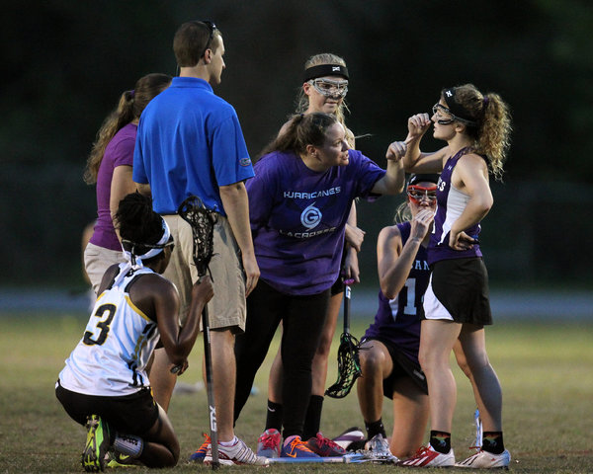
Gainesville High’s Lily Jones, right, was attended to after chipping a tooth during a collision in a game against Buchholz.
Rob C. Witzel for The New York Times
But proponents of the rule point to data that shows that girls’ lacrosse has the fifth-highest rate of concussions in high school sports — only football, ice hockey, boys’ lacrosse and girls’ soccer rank higher. As the Florida High School Athletic Association board of directors was deliberating on whether to approve headgear, it heard emotional testimony from a mother whose daughter had sustained a devastating head injury while playing lacrosse.
“Our board felt it had to do something to provide a level of safety that wasn’t there,” said Dr. Roger Dearing, the Florida high school association’s executive director, whose organization oversees about 4,200 girls’ lacrosse players on 152 teams. “If the goalie in girls’ lacrosse wears a helmet because it’s hazardous to get hit by a ball, then why should the other players be unprotected? If the rule prevents one athlete from a head injury, it is worth it.”
But adding to the backlash against the rule was the Florida board of directors’ decision to ignore the advice of its own operations committee, which unanimously recommended against the new rule. Coaches and parents of athletes appeared before the board to speak out passionately against the measure. US Lacrosse representatives also attended the meeting to contest the rule, explaining how similar measures had been considered in Maryland and New York — and experimented with in Massachusetts — before eventually being dropped.
US Lacrosse, which writes the sport’s rule book authorized by the National Federation of High School Associations, asked Florida officials to delay their vote because US Lacrosse was hoping to propose its own specifications for standardized and lab-tested headgear for girls. It would then recommend voluntary use.
Nine of 14 Florida board members voted for the new rule, eager for it to go into effect this year. The decision did not quiet the opposition.
“My impression was it was an idea whose time will come, but we’re just not there yet,” said Charlene Couvillon, a board member and the principal at Fort Walton Beach High School. She voted against the rule.
Some in the Florida athletic community said they believed the headgear rule had been imposed to evade litigation in a climate of heightened awareness concerning the permanent effects of serious or repeated head trauma.
“I think the F.H.S.A.A.’s primary motivation was the threat of lawsuits,” said Mark Hall, coach of the girls’ team at Coral Shores High School in Tavernier. “You could tell they wouldn’t listen to what others were saying.”
The Value of Helmets
Helmets, while universal in many contact sports, are a frequent source of controversy because of misconceptions about their protective value. Studies have generally indicated that helmets do not protect against many kinds of concussions, although they can help prevent certain kinds of concussions, as well as skull fractures.
Last year, Dawn Comstock, an associate professor of epidemiology for the Pediatric Injury Prevention, Education and Research Program at the Colorado School of Public Health, published a report delineating the different ways that boys’ and girls’ high school lacrosse players sustained head trauma based on Comstock’s nationally recognized injury database. Comstock discovered that most concussions in boys’ lacrosse occurred because of athlete-to-athlete collisions, a finding that did not surprise Comstock because boys’ lacrosse allows full-contact play.
But most of the concussions in girls’ lacrosse occurred when players were struck by the ball or a stick, a finding Comstock said was highly relevant.
“Helmets are very good at preventing direct transfer-of-force injuries,” Comstock said, describing a blow to the head by a stick or a ball. “That’s why we have construction workers wearing helmets.
“The girls’ lacrosse players are at risk. The question is why girls aren’t taking advantage of a part of equipment that boys are taking advantage of.”
As Florida athletics officials have discovered, the easiest way to start a contentious argument in the lacrosse community is to compare the girls’ game with the boys’ game. The biggest fear among girls’ lacrosse coaches and players is that the headgear might make the girls’ game become more like the boys’ game, where contact is so routine and violent that players also wear shoulder, elbow and forearm pads in addition to rigid protective gloves.
“Already, I’ve definitely seen more aggressive play this year,” said Steinberg, the Buchholz senior. “Girls will put their head down and charge after a ball on the ground.”
Hall, the Coral Shores coach, said, “The more protection you put on the head, the more likely they will use it as a weapon.”
It is an old argument, one used in multiple sports, including football in the early part of the 20th century. Ice hockey players in the 1970s insisted that mandatory helmet use would increase the ferocity of the hitting and lead to more injuries, not fewer.
Comstock scoffs at the theory.
“They say protection will create a gladiator effect,” she said. “If the officials enforce the rules and the coaches teach by the rules, then the game cannot change. Athletes cannot play more aggressively unless you allow them to do so.”
Education Is a Tool
There is one thing that all the parties involved in the Florida headgear debate agreed upon. While enacting the new rule, on US Lacrosse’s suggestion, the F.H.S.A.A. agreed to have its game officials go through a training and education program in the rules of the girls’ game to become certified by US Lacrosse. The state also adopted stricter penalties for rough play. To date, nearly 80 percent of registered F.H.S.A.A. officials have completed the program or are one step away from meeting all certification requirements.
While the officials’ training program has been lauded, F.H.S.A.A.’s choice of approved headgear has created acrimony. The organization recommended seven soft-shell models — three that cover the entire head and four that more resemble headbands, with costs ranging from $40 to $70. Most of the models were designed for soccer players, and none have been approved for lacrosse. According to Florida coaches, the vast majority of players have chosen a lightweight, headband-like protection.
Marcy Ross, a longtime certified game official who moved to Florida a few years ago, said the headgear she had seen was “more like a thick bandanna.”
“The only effect the headgear seems to have on the game is more delays,” Ross said. “They fall off, and I have to stop play so a girl can pick up her headband and put it back on. Everyone is laughing.”
But Hall said he had seen a player hit in the head by a ball during a passing drill in practice.
“It bounced off her head, and she was O.K.,” he said. “They may be beneficial.”
US Lacrosse and ASTM International, an organization that develops and publishes standards for a wide range of products, have been working together for years to come up with specifications for approved girls’ lacrosse headgear. Those standards could be agreed upon later this year.
“These will be headgear specifications decided upon based on evidence and research, and not emotion,” Carpenetti, of US Lacrosse, said, adding that athletic equipment manufacturers would then have a standard on which to base their products.
Carpenetti added that some states might decide to mandate the use of the US Lacrosse-approved headgear, while others might make it optional.
“But it’s unlikely that any of the headgear currently being worn in Florida will meet the new standard,” Carpenetti said. “So everyone will have to go out and buy new headgear. I feel badly for those families. It never had to happen this way.”
Dearing, the F.H.S.A.A.’s executive director, said Florida was willing to wait for an approved set of headgear standards but that US Lacrosse had not come up with one in time for this season. Carpenetti argued that US Lacrosse had little sway over the consensus-based approval process at ASTM International and chided Florida officials for recommending equipment that had not met performance standards.
Florida’s lacrosse season is now about halfway over, but the ardent bickering over protective headgear has hardly subsided.
“Florida is the first state to do this, but I don’t expect that we will be the last state to do it,” Dearing said. “Our hope is that we’ll be the catalyst for action on an important issue.”
Ross, the game official who grew up in upstate New York, a lacrosse hotbed, was not rooting for that outcome.
“I hope this rule doesn’t catch on around the country,” she said. “It’s not in the spirit of the game.”

